NEW WORDS :->

1. Revenue :

 income, especially when of an

organization and of a substantia

l nature : "traders have lost £10,000

in revenue since the traffic scheme was implemented"

1. Rook ; means crown (Kawala)
2. Denial : the action of denying something:"she shook her head in denial"
3. ADJUDICATION :
4. Remittance :
5. RTS : Remote Transaction Server
6. **Electronic medical records (EMRs)** are a digital version of the paper charts in the clinician’s office. An EMR contains the medical and treatment history of the patients in one practice. EMRs have advantages over paper records. For example, EMRs allow clinicians to:

* Track data over time
* Easily identify which patients are due for preventive screenings or checkups
* Check how their patients are doing on certain parameters—such as blood pressure readings or vaccinations
* Monitor and improve overall quality of care within the practice

But the information in EMRs doesn’t travel easily *out* of the practice. In fact, the patient’s record might even have to be printed out and delivered by mail to specialists and other members of the care team. In that regard, EMRs are not much better than a paper record.

1. **Electronic health records (EHRs)** do all those things—and more. EHRs focus on the total health of the patient—going beyond standard clinical data collected in the provider’s office and inclusive of a broader view on a patient’s care. EHRs are designed to reach out *beyond* the health organization that originally collects and compiles the information. They are built to share information with other health care providers, such as laboratories and specialists, so they contain information from *all the clinicians involved in the patient’s care*. The National Alliance for Health Information Technology stated that EHR data “can be created, managed, and consulted by authorized clinicians and staff across more than one healthcare organization.”

The information moves with the patient—to the specialist, the hospital, the nursing home, the next state or even across the country. In comparing the differences between record types, HIMSS Analytics stated that, “The EHR represents the ability to easily share medical information among stakeholders and to have a patient’s information follow him or her through the various modalities of care engaged by that individual.” EHRs are designed to be accessed by all people involved in the patients care—*including the patients themselves*. Indeed, that is an explicit expectation in the Stage 1 definition of “[**meaningful use**](http://healthit.hhs.gov/meaningfuluse)” of EHRs.

And that makes all the difference. Because when information is shared in a secure way, it becomes more powerful. Health care is a team effort, and shared information supports that effort. After all, much of the value derived from the health care delivery system results from the effective communication of information from one party to another and, ultimately, the ability of multiple parties to engage in interactive communication of information.

1. Exception: 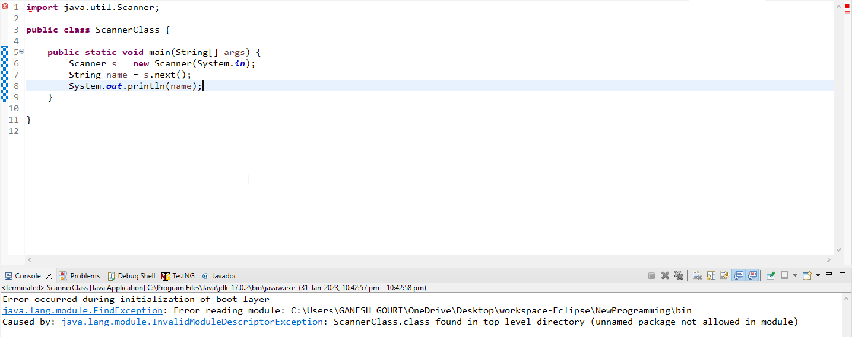
2. TM :- TradeMark
3. Codes for colors:-
4. --blue: #007bff;
5.  --indigo: #6610f2;
6.  --purple: #6f42c1;
7.  --pink: #e83e8c;
8.  --red: #dc3545;
9.  --orange: #fd7e14;
10.  --yellow: #ffc107;
11.  --green: #28a745;
12.  --teal: #20c997;
13.  --cyan: #17a2b8;
14.  --white: #fff;
15.  --gray: #6c757d;
16.  --gray-dark: #343a40;
17.  --primary: #007bff;
18.  --secondary: #6c757d;
19.  --success: #28a745;
20.  --info: #17a2b8;
21.  --warning: #ffc107;
22.  --danger: #dc3545;
23.  --light: #f8f9fa;
24.  --dark: #343a40;
25. feasibility of automation:-
26. 1.introduce yourself

Ans:- First off all thank you for giving me this opportunity for introducing myself. I am Komal P. Gawali and I completed my graduation and post-graduation from rastrasant tukdoji maharaj , Nagpur univercity

1. 2.which lang. u use in your organization?(python/java)
2. 3.what u can do in selenium ?
3. 4.are u a quick learner ?
4. 5.are u currently fully shifted to automation ?
5. 6.have u create the framework from scratch or just use the framework which is already bulid.
6. 7.have u create the testcase in framework or fisrt Create and then later add it in framework
7. 8.what are the other testing u performance
8. 9.have u do api testing deeply or just a besic knowledge about it
9. 10.what is multithreding 11. Have u performed parallel testing
10. 12.what is ci/cd how it is work
11. 13. If u are automated test case & some testcases gets failed what is your approch for that
12. 14.what defect manegment tool u used & how u rised defect In it
13. 15.which methodology u follow
14. 16. Agile ceremonys
15. 17.how u know defect is valid which u have rised
16. 18.have u worked with client closely
17. 19.what are different environments
18. 20.which testing u performed first
19. 21.what are different http method tell me something for each
20. 22.tell me about u project & team size
21. 23what are thing u covered in traceability matrix
22. 24.what is globalization testing
23. 25.where are u from ?
24. 26. Do u have any questions for me
25. TCS
26. First Round
27. 1.introduction
28. 2.Which framework have u used ?
29. 3.Explain Framework
30. 4.gettext
31. 5.findelement & find elements difference
32. 6.Testng annotations & sequence
33. 7.what is testng ?
34. 8 what is priority give some scenarios like priority 1,2,0 & asked which test case run first
35. 9.what is Pom
36. 10.mouse action
37. 11.how to handle frame
38. 12.how to handle link
39. 13.how to handle file uploading
40. 14.advantages of pom
41. 15.is displayed method
42. 16.webelement method
43. 17. Type of locators
44. 18.css selector
45. 19.where u used before suit & aftersuit
46. 20.how to take screenshot in selenium & syntax
47. TCS
48. 2nd Round
49. 1.tell me about your self
50. 2.Which framework u have used ?
51. 3. What is Pom
52. 4.Pom.xml
53. 5.how to get data from testing
54. 6.when u used before method
55. 7.what is parameters
56. 8.implicit wait & syntax
57. 9.Explicit wait & syntax
58. 10.how to handle iframe
59. 11.if u have have tagname = input & attribute tell me how to write Xpath
60. 12.diff bet findelement & findelements
61. 13.what is selenium webdriver
62. 14.method of webdriver
63. 15.Explicit wait condition
64. 15.how to run automatic test scripts
65. 16.how u handle exception in selenium
66. 17.when come stale element?
67. 18.which tool used for reporting
68. 19.you know ci/Cd
69. 20.what is log4j
70. 21.which tool have u used for defect tracking
71. 22.which process u used in project
72. 23.agile ceremony
73. 24.Explain Retrospective meeting
74. 21. 21. This and super keyword in java
75. 22. 22. Issues during Swtich case without break
76. 23. 23. Upcasting and downcasting
77. 24. 24. Baseclass of all class in java
78. 25. 25. Baseclass of error and exceptions
79. 26. 26. Access specifiers
80. 27. 27. Continue and break statement
81. 28. 28. Can main method return any value
82. 29. 29. Can we overload main method. What happens when overloaded
83. 30. 30.how to execute and statement before main method
84. 31. 31. Difference between == and equals()
85. 32. 32. Can user declare constructor as final
86. 33. 33. Can we cast any other type to Boolean data with type casting.
87. 34. 34.does java compile if user use 'static public void' instead of 'public static void'
88. 35. 35.can we use this() and super() in a constructor
89. 36. 36. Can we create object of abstract class
90. 37. 37. Can we create reference for an abstract class
91. 38. 38. Can we declare a class as static
92. 39. 39. What is instanceOf keyword
93. 40. 40. What's the load factor of HashMap
94. 41. 41. How to prevent a class from being sub classes
95. 42. 42. Final variable, final method and final class
96. 43. 43. Ways to create a string variable.
97. 44. 44. What is gc() - garbage collector
98. 45. 45. Subclass and innerclass
99. 46. 46. Infinite loop in java
100. 47. 47. How to make copy of an element
101. 48. 48. Checked and unchecked exceptions
102. *
103. Java Collection
104. *
105. 1. Classes inside List interface, Set interface, Map Interface
106. 2. 2. Arraylist vs Linkedlist
107. 3. 3. Arraylist vs array
108. 4. 4. Arraylist vs vector or stack
109. 5. 5. Which class of List Interface to be used if user have more insertions and deletions
110. 6. 6. Which class of List Interface to be used if user have more retrieval
111. 7. 7. Set Interface: HashSet, TreeSet, SortedSet
112. 8. 8. Map - HashMap, HashTable, TreeMap, LinkedHashMap.
113. 9. 9. Stack and Queue
114. 10. 10. How to maintain insertion order in Set, List and Map
115. 11. 11. How to sort elements in ascending order in Set and Map
116. *
117. Java Programs
118. *
119. 1. String reverse
120. 2. 2. String Palindrome
121. 3. 3. String Anagram
122. 4. 4. Find occurrences of characters in a string
123. 5. 5. Find the count of Capital and Small letters in a string
124. 6. 6. Remove duplicate characters from string
125. 7. 7. Swap to numbers without temporary variable
126. 8. 8. Reverse number
127. 9. 9. factorial
128. 10. 10. Fibonacci
129. 11. 11. Count number, alphabet and special characters
130. *
131. Selenium
132. *
133. 1. Difference in driver.get() and driver.navigate().to()
134. 2. 2. Navigation methods in selenium
135. 3. 3. What is POM
136. 4. 4. Implicit wait
137. 5. 5. Explicit wait- use of explicit wait, how to ignore exceptions using explicit wait
138. 6. 6. Fluent wait
139. 7. 7. Examples for expected conditions in explicit wait
140. 8. 8. Default timeout of pageLoadTimeout.
141. 9. 9. Use of desired capabilities
142. 10. 10. Use of chromeOptions, firefoxOptions ,ieOptions, etc.
143. 11. 11. How to disable notification in selenium.
144. 12. 12. Difference between getText() and getAttribute()
145. 13. 13. How to extract css property value
146. 14. 14. Difference between driver.close() and driver.quit()
147. 15. 15. How to handle dropdown elements with select tag and without select tag.
148. 16. 16. How to handle frames and windows
149. 17. 17. How to switch back to parent window.
150. 18. 18. How to perform page scroll in selenium
151. 19. 19. Use of Robot keys
152. 20. 20. Use of AutoIt
153. 21. 21. Use of Sikuli
154. 22. 22. How to perform File Upload
155. 23. 23. How to click or send value to an element without using element.click() and element.sendKeys()
156. 24. 24. Relative and absolute xpath
157. 25. 25. Explain few Xpath functions
158. 26. 26. How to login to site showing authentication popup in selenium
159. 27. 27. Mention few selenium exceptions
160. 28. 28. Difference between single slash and double slash.
161. 29. 29. What are the scenarios that cannot be automated using selenium.
162. 30. 30. How to perform right click on selenium
163. Equivalence class:-